## Getting Started

This document explains how to download, install and start MiServer for the first time.

## Download MiServer 3.0

You can download MiServer by

1. going to **https://github.com/Dyalog/MiServer** and
2. clicking the "Download Zip" button

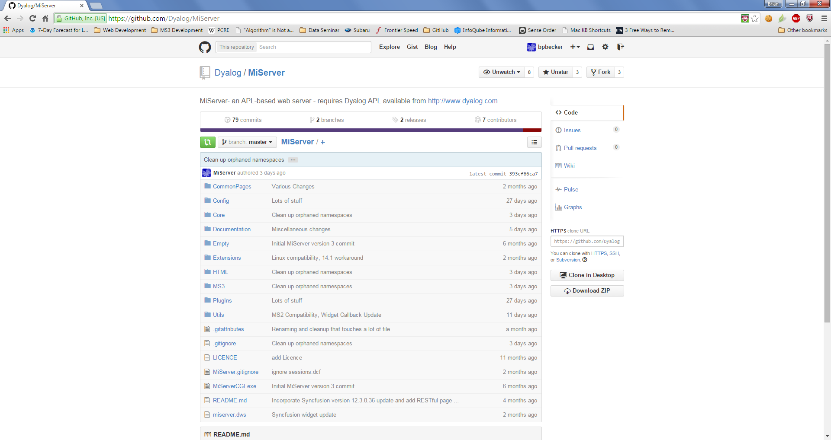

There is also the option to clone the MiServer 3.0 repository in the Desktop version of Git. This is a good option if you want to keep up to date with the latest developments in MiServer and/or participate in the MiServer community by submitting your code for consideration of inclusion in the GitHub repository. If you choose to clone, skip to Install MiServer 3.0.

## Install MiServer 3.0

Whether you have a zip file or have decided to clone the GitHub repository, you'll need to select a folder in which to install MiServer.



How you plan to use MiServer may influence where you install it.

If you're planning on running MiServer locally for your own use, or as a development environment, good folders include:

* Your desktop folder – the miserver workspace will be easily clickable
* Your My Documents folder
* A folder off of the root folder (e.g. c:\miserver\)

If you're planning to host this installation of MiServer

* A folder off of the root folder (e.g. c:\miserver\)



It is NOT recommended that you install MiServer where Dyalog APL is installed.

For the remainder of this document we'll use "c:\miserver3\" as the place where we've installed MiServer.

So, substitute your actual location whenever you see "c:\miserver3\"

## Start MiServer 3.0

1. Load the miserver workspace

**)load c:\miserver3\miserver**

c:\miserver3\miserver.dws saved...

Start 'MS3' ⍝ Run the MiServer v3.0 sample site

1. Start MiServer

Cursor up, insert a 1 before Start and press enter

**1 Start 'MS3'** ⍝ Run the MiServer v3.0 sample site   
Development environment loaded

MiSite "c:\miserver3\MS3" loaded

MiServer for "MS3" started on port: 8080 Running in Debug mode (configured by setting <Production> in /Config/Server.xml)

What's all this mean?

* Development environment loaded  
  Providing Start a left argument of 1 loads the development environment which loads all the classes needed to be able to edit pages from the root of the workspace.
* MiSite "c:\miserver3\MS3" loaded  
  The right argument to Start is the path to your website. If you specify 'MS3' (a relative path), MiServer starts its built-in website located in the /MS3 folder.
* MiServer for "MS3" started on port: 8080   
  This means that MiServer started successfully and listening on port 8080. The port is configurable.
* Running in Debug mode (configured by setting <Production> in /Config/Server.xml)  
  Debug mode was added to MiServer 3.0 to make it easier recover and carry on when an error occurs - generally when some invalid data was passed to a widget.

1. Use the browser of your choice to navigate to **http://localhost:8080**